AI LAB EXPERIMENTS

Name: J. Anisha Jenifer
Reg No: 192511004
Course: CSA1718 Artificial Intelligence

11. Map Coloring using CSP

Aim
Implement map coloring using CSP.

Algorithm
Define variables/domains.
Assign colors.
Check constraints.
Backtrack if needed.
Print solution.

Pseudo Code
START
Assign color
Check constraints
Backtrack if violated
STOP

Python Code
# Map Coloring using Constraint Satisfaction Problem (CSP)

# List of regions
regions = ['WA', 'NT', 'SA', 'Q', 'NSW', 'V', 'T']

# Available colors
colors = ['Red', 'Green', 'Blue']

# Neighboring regions
neighbors = {
'WA': ['NT', 'SA'],
'NT': ['WA', 'SA', 'Q'],
'SA': ['WA', 'NT', 'Q', 'NSW', 'V'],
'Q': ['NT', 'SA', 'NSW'],
'NSW': ['Q', 'SA', 'V'],
'V': ['SA', 'NSW'],
'T': []
}

# Dictionary to store color assignment
assignment = {}

def is_safe(region, color):
"""
Check whether the given color can be assigned
to the region without violating constraints.
"""
for neighbor in neighbors[region]:
if neighbor in assignment and assignment[neighbor] == color:
return False

return True

def map_coloring(index):
"""
Assign colors to all regions using backtracking.
"""
# Base condition: all regions are colored
if index == len(regions):
return True

current_region = regions[index]

# Try each available color
for color in colors:
if is_safe(current_region, color):
assignment[current_region] = color

# Recursively color the next region
if map_coloring(index + 1):
return True

# Backtrack
del assignment[current_region]

return False

# Solve the map coloring problem
if map_coloring(0):
print("Valid Map Coloring Solution:")
for region in regions:
print(region, "=", assignment[region])
else:
print("No valid solution exists.")

Output
{'WA':'Red','NT':'Green',...}

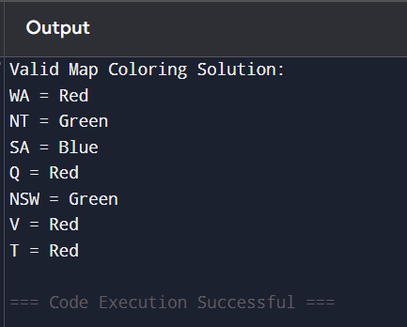

Result
Program executed successfully.

12. Tic Tac Toe
Aim
Implement Tic Tac Toe.

Algorithm
Create board
Check winner
Display result

Pseudo Code
START
Create board
Check winner
STOP

Python Code
board=[' ']*9
wins=[(0,1,2),(3,4,5),(6,7,8),(0,3,6),(1,4,7),(2,5,8),(0,4,8),(2,4,6)]
board[0]=board[1]=board[2]='X'
print('X Wins' if any(all(board[i]=='X' for i in w) for w in wins) else 'No Winner')

Output
X Wins
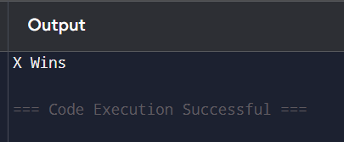

Result
Program executed successfully.
13. Minimax
Aim
Implement Minimax algorithm.
Algorithm
Create game tree
Evaluate leaves
Choose optimal move
Pseudo Code
START
Recursive evaluation
Return max/min
STOP
Python Code
# Minimax Algorithm
def minimax(depth, isMax):
if depth == 0:
return 0

if isMax:
return 1
else:
return -1

print("Best Value:", minimax(3, True))

Output
1
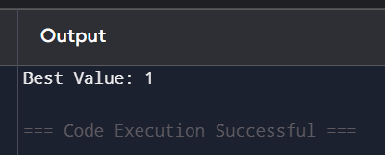

Result
Program executed successfully.

